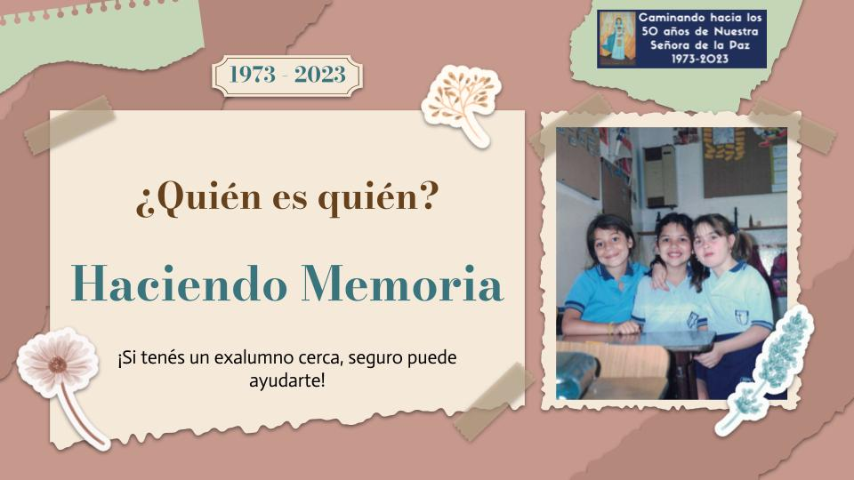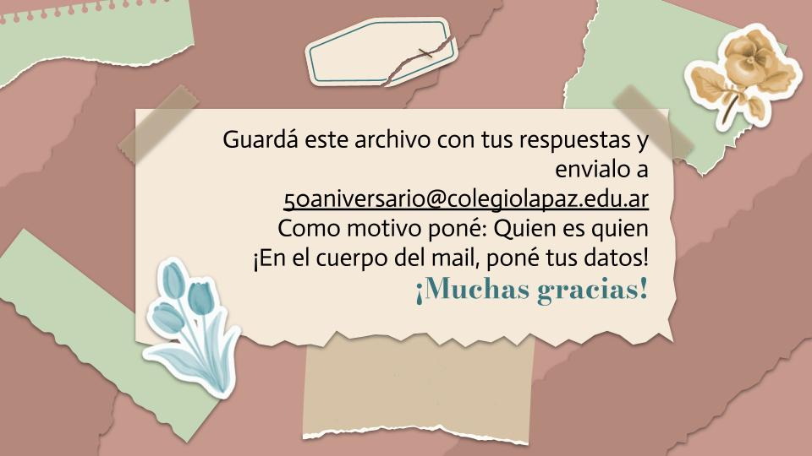

**Tus datos**

**Nombre y apellido:**

**Mail:**

**Contanos tu Relación con el Colegio (por ejemplo, soy exalumno/a, soy madre/padre de exalumno/a, …):**

|  |  |
| --- | --- |
| https://lh5.googleusercontent.com/qEFcWutHzz3-QIvwBOC4KeWRFr_vd6_xrkZ1TXRZoVb7cC0jOySC1s0DjL0Gxdhm0--RWfGZNg-ZlkJ2g6dNvxJGIAkhahIIgBYmT3blFIaqaDZsjJGxxKIkriE9tCPlE96WK3QCp5KwEu7pzNHcaQ | **FOTO 1:** |

|  |  |
| --- | --- |
| https://lh4.googleusercontent.com/A0cmS_jVDliux3sL0SP8CrmEPbNIZ08FCqyY5d2_EBa3ygqy99JDx8UgO22_3iiSkR4P0H37aeaKzR_78XVMYkshZNNFBUGQgOlzIWDQGlilw7HodS3-IGGn9GH-tuUcdcFFeilodHSrsQvmNSKzxw | **FOTO 2:** |

|  |  |
| --- | --- |
|  | **FOTO 3:** |

|  |  |
| --- | --- |
|  | **FOTO 4:** |
|  | **FOTO 5:** |

|  |  |
| --- | --- |
|  | **FOTO 6:** |

|  |  |
| --- | --- |
|  | **FOTO 7:** |

|  |  |
| --- | --- |
|  | **FOTO 8:** |

|  |  |
| --- | --- |
|  | **FOTO 9:** |

|  |  |
| --- | --- |
|  | **FOTO 10:** |